Spread Happiness Project Letter Template

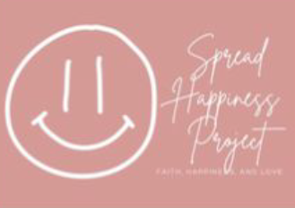

For a Reciprocated Letter (pen pal):
<<<Your Name>>>
<<<Home or Work Address>>>
<<<Home or Work Address>>>
<<<Home or Work Address>>>

Dear Friend,
My name is <<<name>>. I work at UNC-Chapel Hill in <<<School/Division/Department>>>. I’m participating in the Spread Happiness Project. Our goal is to bring a little bit of joy, happiness and love to those living in nursing care and assisted living housing.
<<<Body Example 1 – Reciprocated Letter (pen pal)>>>
I hope you have been enjoying the weather as it has been warming up. My family and I love to be outside when the weather is nice. I love hearing the birds chirp and seeing them fly around outside the window. What is your favorite type of bird or animal?

<<<Body Example 2 – Reciprocated Letter (pen pal)>>>
This summer will be a little different than last summer: My husband and I recently had a baby, so we are excited to be able to bring the baby to the beach and to have her swim in the pool this summer—she started swimming lessons at 5 months old! Summer is my favorite season, and I’m looking forward to it now more than ever. What’s your favorite season and what do you enjoy most about it?

<<<Body Example 3 – Reciprocated Letter (pen pal)>>>
UNC-Chapel Hill men's basketball made it to the National Championship game this year! We unfortunately lost to Kansas, but it was a great game. The players worked so hard and did very well. It was such a fun team to watch. Do you enjoy sports and have a favorite sports team?

For a One-Time Letter:

<<<Body Example 1 – One-Time Letter >>>
I’m so excited the weather has been warming up! It’s been great to just sit outside and soak up the sun and enjoy the sounds of nature. My family and I like to walk our dogs in this weather. We have two dogs—a Chorkie and a German Shepard—and they love the outside. Our Chorkie is named Jersey, and our German Shepard is Jazz. Jersey was named after New Jersey, where I am originally from, and Jazz was named after jazz music because my husband loves jazz music.>>>

I know during this time, and throughout Covid-19, it has been so hard for everyone to stay connected, so I wanted to reach out to let you know that you are cared for, wanted and important. I hope that this letter brought a smile to your face and brightened your day.

<<<For a response>>>
Feel free to write back at my address above. I look forward to hearing from you.

<<<Sample closing>>>
Have a wonderful day,
<<<Your Name>>

